**3rd ATTEMPT**

1. CREATE NEW REPOSITORY

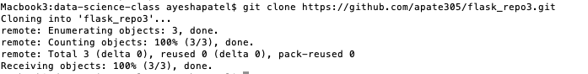

1. MOVED FLASK_DEMO INTO NEW REPOSITORY (flask_repo3) [did a git push!]
2. USED FOLLOWING INSTRUCTIONS TO CREATE .gitignore file IN REPOSITORY

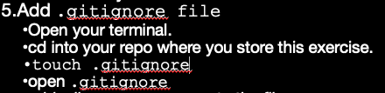

Added the following into the .gitignore (last 2 are the relevant ones): [did a git push again!]

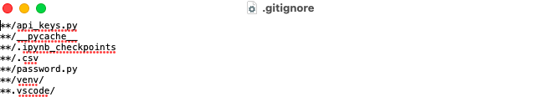

1. MADE SURE FLASK APP WORKS:

export FLASK_APP=flask-app

Macbook3:flask_demo ayeshapatel$ flask run

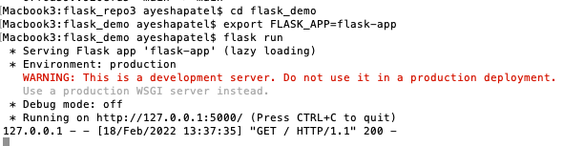

<http://127.0.0.1:5000/>

Hello World!

[http://127.0.0.1:5000/gdp](http://127.0.0.1:5000/gdp/)

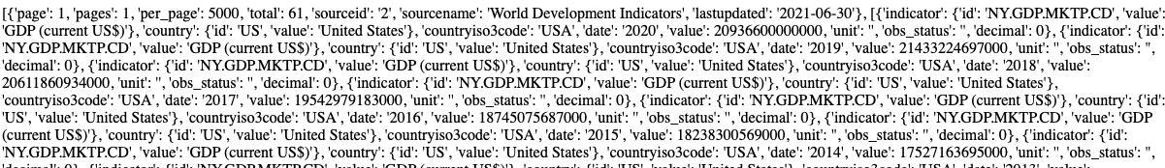

<http://127.0.0.1:5000/gdp/2003>



1. GO TO AZURE PORTAL: portal.azure.com AND CREATE RESOURCE GROUP

Click “Create” under web app in APP services



Create Web App page looks like this:

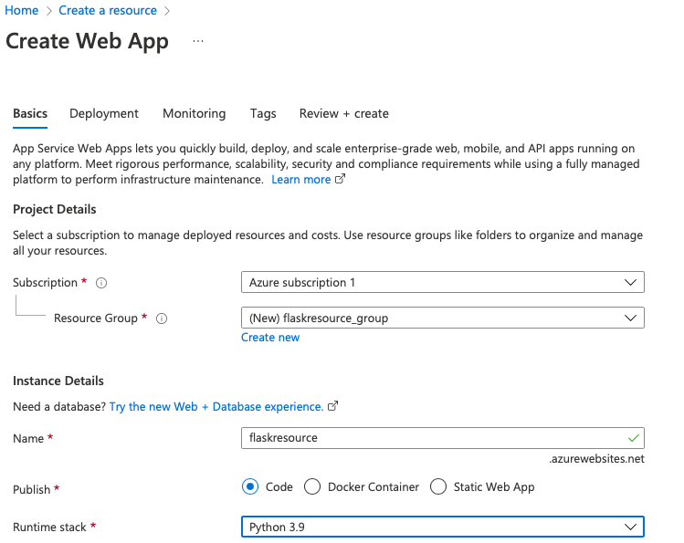

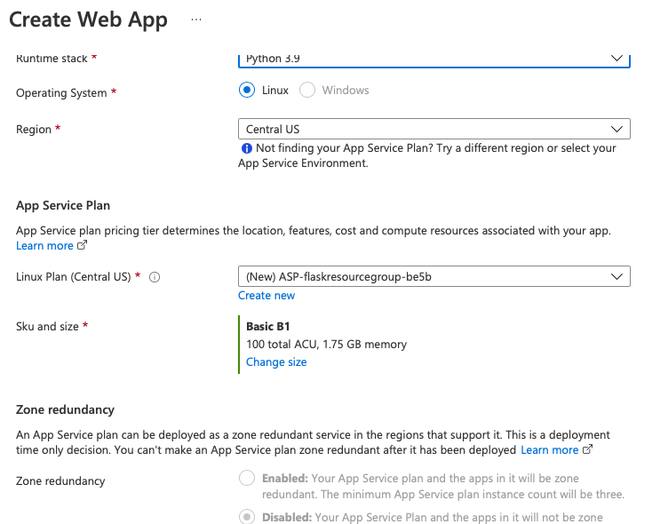

Validation Page looks like this:

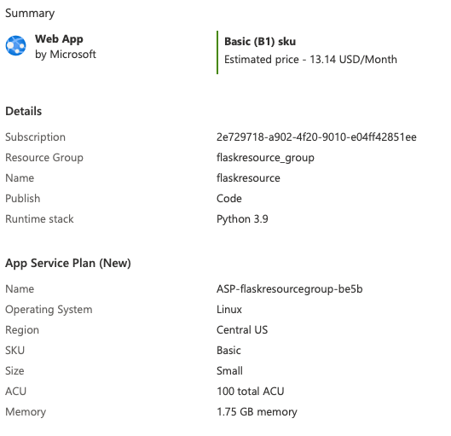

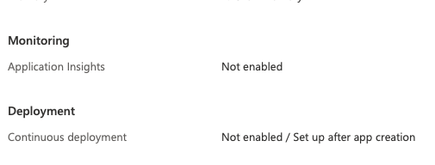

1. SETTING UP DEPLOYMENT CENTER

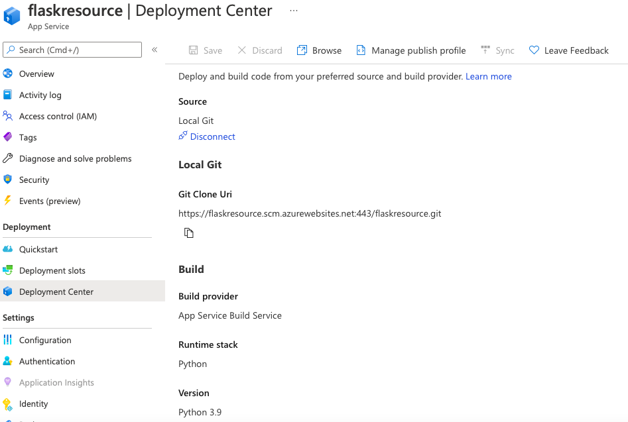

Adding password and username under user scope[hit save]:

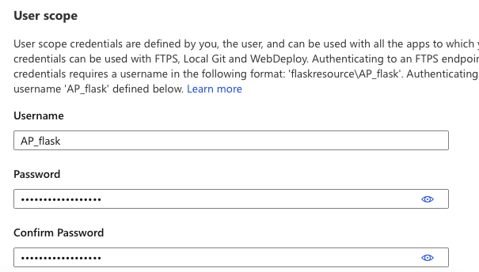

**I tried other commands in my terminal since the commands from the instructions didn’t seem to work.**

1. 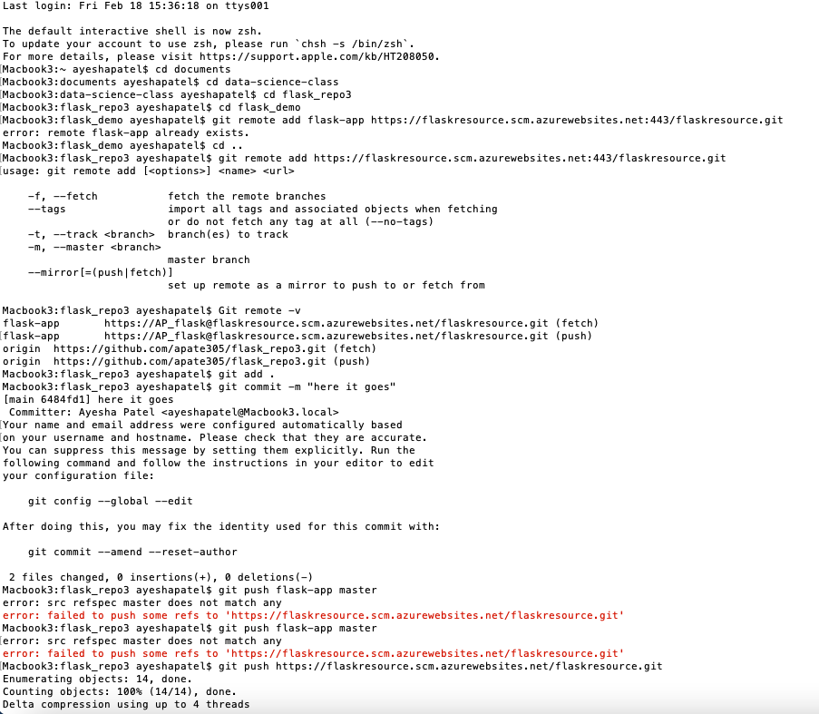

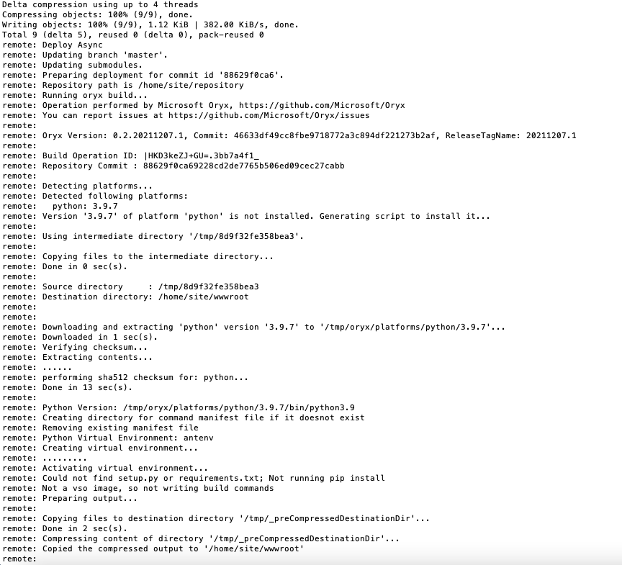

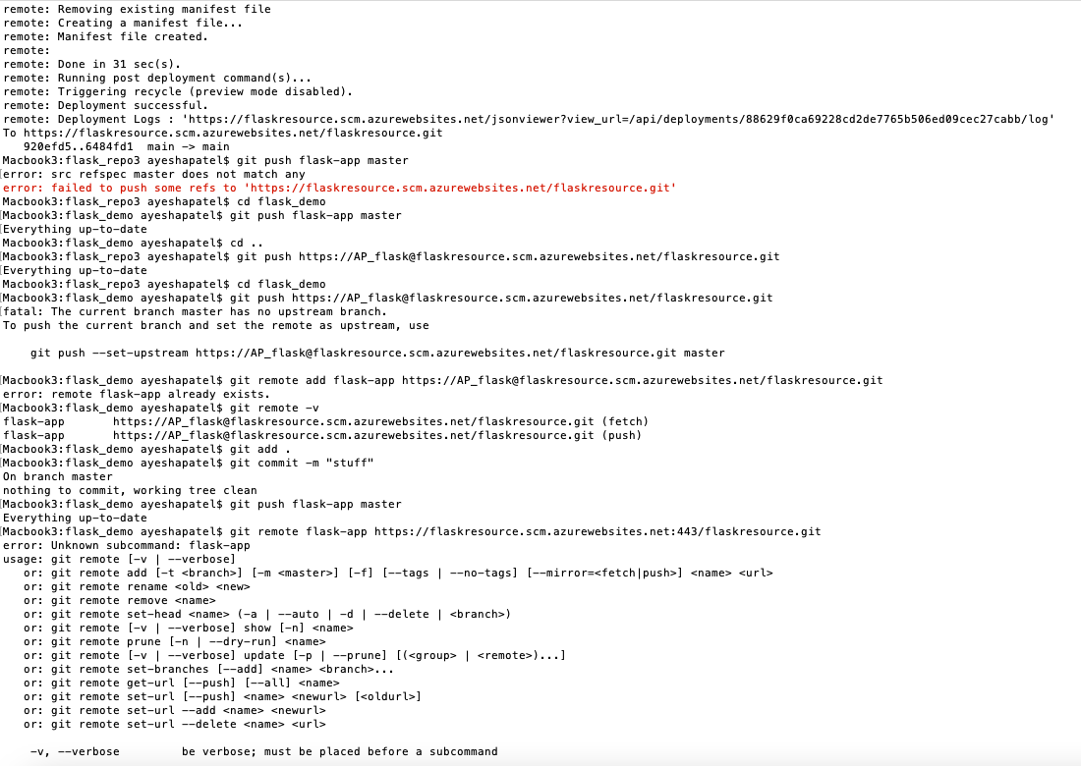

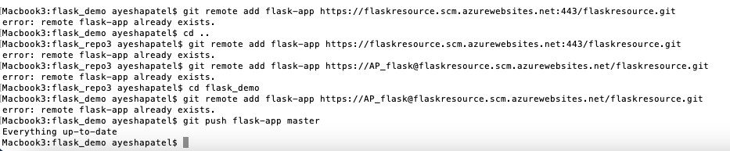

1. Adding the following to my startup command : gunicorn -- bind=0.0.0.0 --timeout 500 flask-app:app
2. 